**vidArt: extraction of dynamic artery parameters from B-mode video recordings**

**Ultrasound system**

The vidArt program extracts morphological (artery diameter, wall thickness and wall irregularity) and dynamic characteristics (distension waveforms) along a selected segment of a peripheral artery, e.g. the common carotid artery, from B-mode ultrasound (US) recordings (B: brightness mode, i.e., echo level is encoded and presented as brightness). For peripheral arteries at a depth on the order of 2-3 cm, the ultrasound resolution will be about 0.25 mm in depth and 1 mm in the lateral direction. For a depth range of 40 mm and 128 lines per image the maximal frame rate will be on the order of 50 frames per second. To have smooth presentations, the 2D echo-image is acquired with an echo-line density of 3 per mm and sampled in depth at a rate of 1 sample per 0.1mm, i.e. at about 1/3 of the resolution in either direction. The 2D image is interpolated in the lateral direction to arrive eventually at a square per sample, e.g., an echo image of 400 by 400 pixels for a field of view of 40 by 40 mm. The echo image is surrounded by supporting information, explaining that the US monitor should be able to accommodate images of 1000 by 800 pixels.

**Video recording characteristics**

The vidArt-program processes B-mode ultrasound (US) video-sequences, recorded either in avi- or in DICOM-mode, to extract the (change in) artery lumen diameter and intima-media thickness (IMT) over a few cardiac cycles (typically 5-10) along an artery. The standard transducer position is at the top of the image. Superficial arteries in a longitudinal view will be presented in the horizontal direction. One should realize that for video-recording (e.g. DVD) the B-mode image presented by the ultrasound system is reduced to a common video standard, i.e. 640*480 pixels at 25 Hz. For a good resolution, it is henceforth essential that the artery of interest covers a large depth range (‘zoom’-function). On the other hand, zoom will modify pixel to mm scaling. So decide in advance what approach (depth-range, zoom) will be followed. The DICOM-standard might be more convenient because it allows a frame-rate consistent with the actual frame-rate of the ultrasound system at a better resolution (more pixels). Moreover, DICOM files contain additional information about image acquisition, including the actual scaling from pixels to mm.

**Ultrasound characteristics**

Ultrasound imaging is based on the concept that part of the emitted ultrasound signal is reflected/scattered by acoustic interfaces, i.e., boundaries of regions with different acoustic impedance and sensed by the transducer where the amplitude of the echo is converted to a grey scale value. Acoustic interfaces that are large with respect to the wavelength of the ultrasound cause the angle of reflection to mirror the angle of incidence. Is the dimension small, then scattering in all directions will occur. Note that in contrast with other imaging modalities, homogeneous structures do not provide no ultrasound information. Assuming that all tissues exhibit the same sound speed (c=1540 m/s), the time elapsing between emission and reception directly reflects the depth at which the acoustic interface is located (t=**2**\*depth/c).

The applied ultrasound frequency is a compromise between resolution and the frequency dependent attenuation of 1 dB per MHz per cm. A high frequency (short wavelength) provides an excellent resolution but a very limited depth of penetration. That is why for murine applications a frequency of 30 MHz (wavelength 50 mu, penetration <10 mm) is used, while for human cardiac applications standard 3.5 MHz is selected. For peripheral vascular applications commonly a frequency of 7 MHz (wavelength 210 um) is selected. The relation between wavelength λ and frequency f is given by c=λf where c is sound speed (in human tissue around 1540 m/s).

The length of a signal pulse, expressed in periods, equals the quality factor Q=fc/B with fc and B the center frequency and bandwidth of the signal, respectively. Note that manufacturers and salesmen of ultrasound equipment that the customers like to be lured by false promises, hence, they quote falsely the upper edge of the bandwidth as emission frequency and deny the relevance of bandwidth. A common value for Q=2 (it remained more or less the same in the past 40 years) and applies to the emitted signal as well as the received signal, despite a frequency dependent attenuation of 1 dB per MHz per cm causing an apparent downward shift of the center frequency. We can now define the **depth resolution**. Because of a Q of, for example, 2 reflectors should be spaced at least one period (wavelength) to appear disjoint in a round trip observation. The **lateral resolution** in the plane of observation at the focal point of a well focused beam is about 4-5 wavelengths. In the azimuth plane a mechanical focus takes care for a single focal point (the natural focus is about 0.6 times the transducer width in that plane at a distance of d2/4λ). Both the depth and lateral resolution are essential for the current program since they define how features will be grouped or analyzed independently.

**Main menu**

The program starts with the Settings menu displaying the default settings (at the first call) or the settings as used in the last setting (this might be confusing if multiple users on the same computer system consider images acquired with different systems or transducers). Those settings (and some others) will be saved in a ‘vArtSett.mat’ file within the start-up folder of ‘vidArt.exe’. The meaning of some of the settings will become evident while scrolling through this manual and the program. Note that at this stage you have to make the selection whether you want to consider either distension waveforms or both distension waveforms and IMT detection (the latter is far more elaborate). After returning to the Main Menu you can select either to evaluate a video-clip or to reconsider a previously analyzed sequence (earlier results).

The next step is the selection of the type of video-input (avi, DICOM with or without extension). Note that the absence of a file extension may create confusion regarding the nature of a file; nevertheless most US systems provide DICOM-files without extension. The option ‘General information’ provides some details about the vidArt program. The version number is composed of the year and month of the release and is certainly not a sequence number.

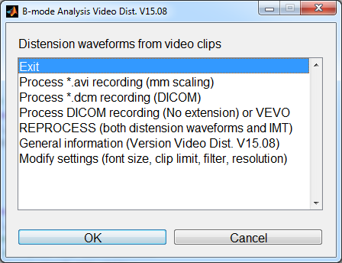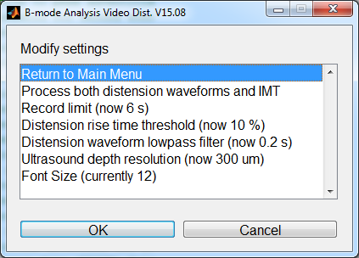

*Fig. 1 Main menu vidArt program (left) and sub menu with settings Right)*

**Region of interest**

The selection of a video-file is followed by a review of the video movie, offering the option to exclude motion/recording artifacts at the beginning/end of the video-sequence. In the example below we will consider a peripheral vascular examination. Processing starts with the identification of a region of interest (ROI) covering the artery of interest over at least 50 percent of the image width and including above and below at least 5 depth resolutions of tissue (fig.2), i.e. 25% of the lumen diameter for an artery with a diameter of 6 mm. For peripheral vascular imaging with a 7.5 MHz system the actual emission frequency will be about 5 MHz and the depth resolution on the order of 250-300 um. The user will be prompted to readjust the window if it is too small. Note that in fig. 2 horizontal and vertical positions are indicated in pixel units (traditionally 650 by 480 pixels). The actual image covering a depth of 30 mm (see markers at left side of the B-mode image in fig. 2) utilizes about 350 pixels, i.e. a vertical pixel distance of 90 micron

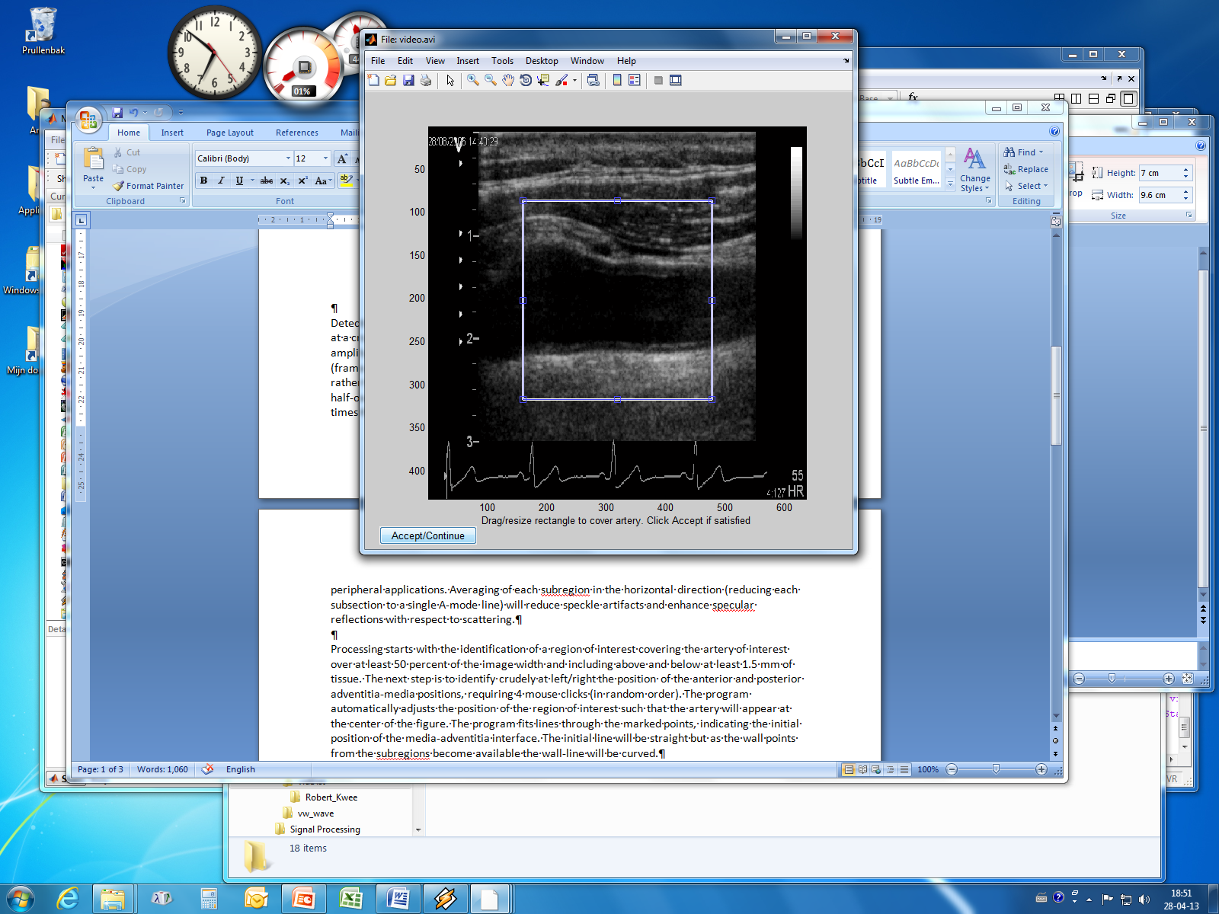

*Fig.2: Selection of the region of interest*

The example presented here has intentionally a poor B-mode quality (curved and diverging artery segment with poor contrast, substantial secondary reflections within the lumen, probe motion artifacts) to fully appreciate the performance of the vidArt program. The granular pattern in the figure is caused by phase interference (speckle) of echoes from targets within the 3-dimensional resolution volume.

**Wall/lumen identification**

The next step is to identify crudely at left/right the position of the anterior and posterior adventitia-media positions (fig. 4), requiring 4 mouse clicks (in random order). The program automatically adjusts the position of the region of interest such that the artery will appear at the center of the figure. The user will be prompted to readjust the window size if the walls appear too close to the window edges.

The program fits lines through the marked points, indicating the initial position of the media-adventitia interface. The initial line will be straight but as the wall points from the subregions become available the wall-line will be curved as illustrated in fig. 4 after the first video-frame is processed. For clarity the artery center (dashed line) is also indicated.

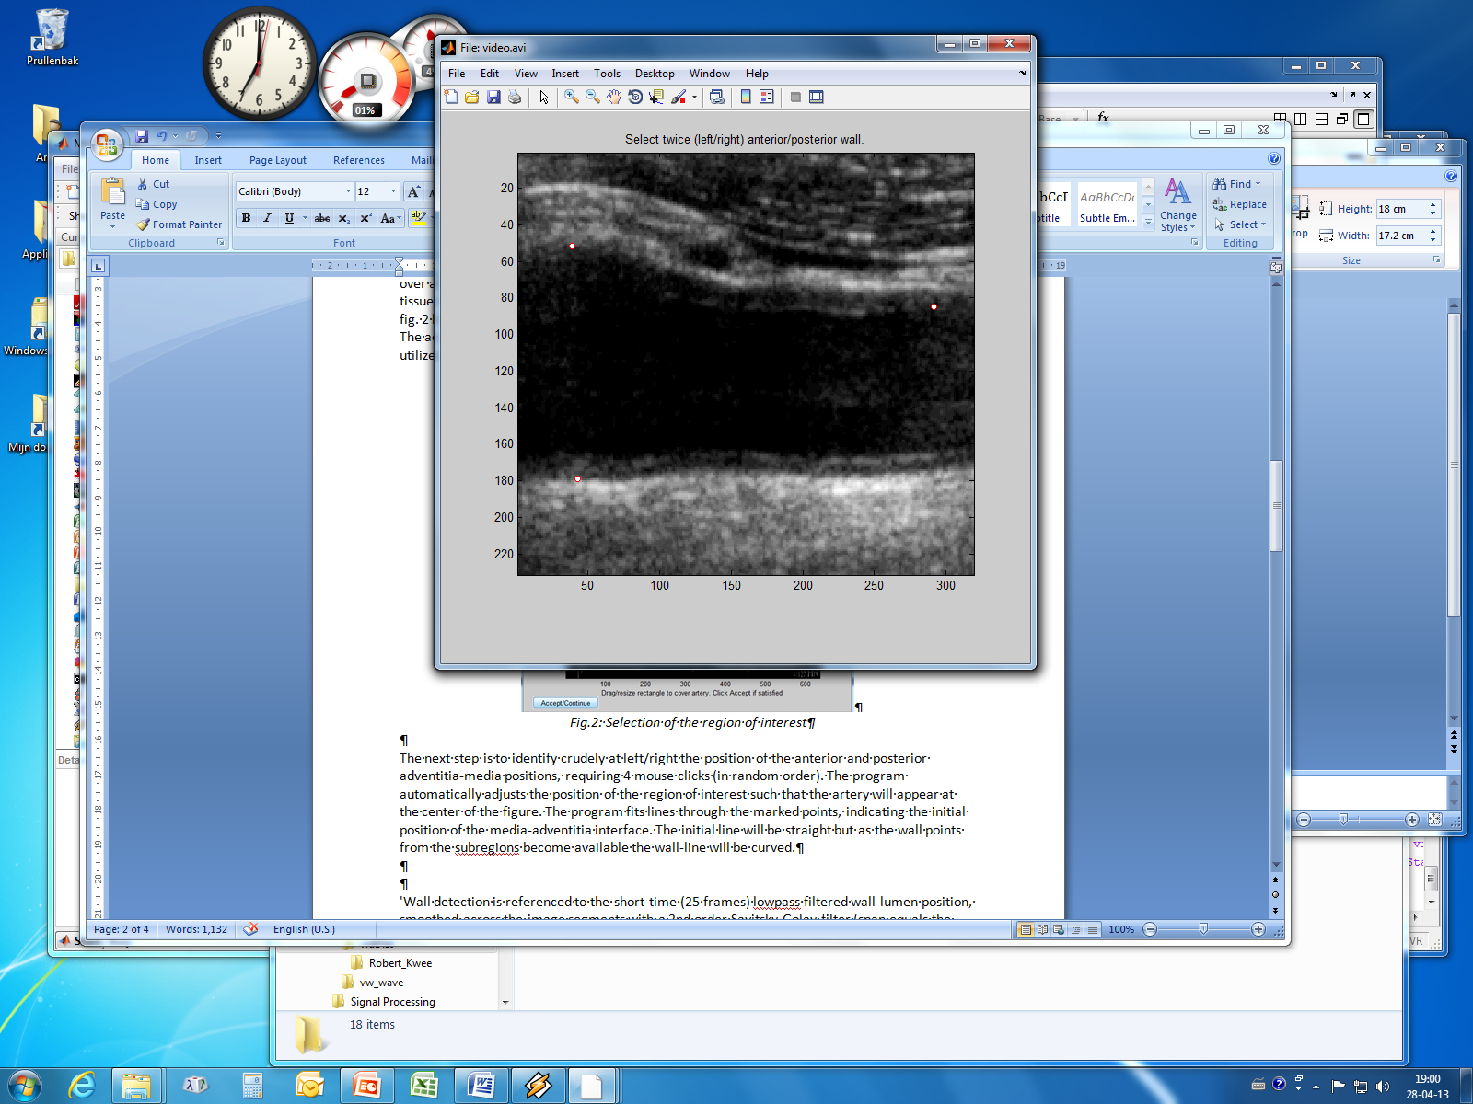

*Fig. 3 Markers for identification initial position anterior/posterior walls (the program is waiting for the last marker position).*

**Wall detection**

The pull-down menu at the left bottom of fig. 4 selects display of the actual B-mode image with wall overlay or the processing progress of the anterior/posterior wall (fig. 5). Note that for a video of only 6 seconds and about real-time processing the option is only shortly available. Detection of the lumen-wall transition at subsequently the anterior and posterior walls is based at a level crossing within a few mm of the wall of an amplitude threshold relative to the nearby adventitia amplitude. Because the video-approach sacrifices spatial (pixel density) and temporal (frame-rate) resolution, the current program considers a local spatial average for wall detection rather than the individual echo-lines. For that purpose, each image is split up in a number of half-overlapping vertically oriented sub-regions (called blocks, about 15) with a width of about 3 times the estimated lateral resolution of the echo-system. Averaging of each subregion in the horizontal direction (reducing each subsection to a single A-mode line) will reduce speckle artifacts and enhance specular reflections with respect to scattering.

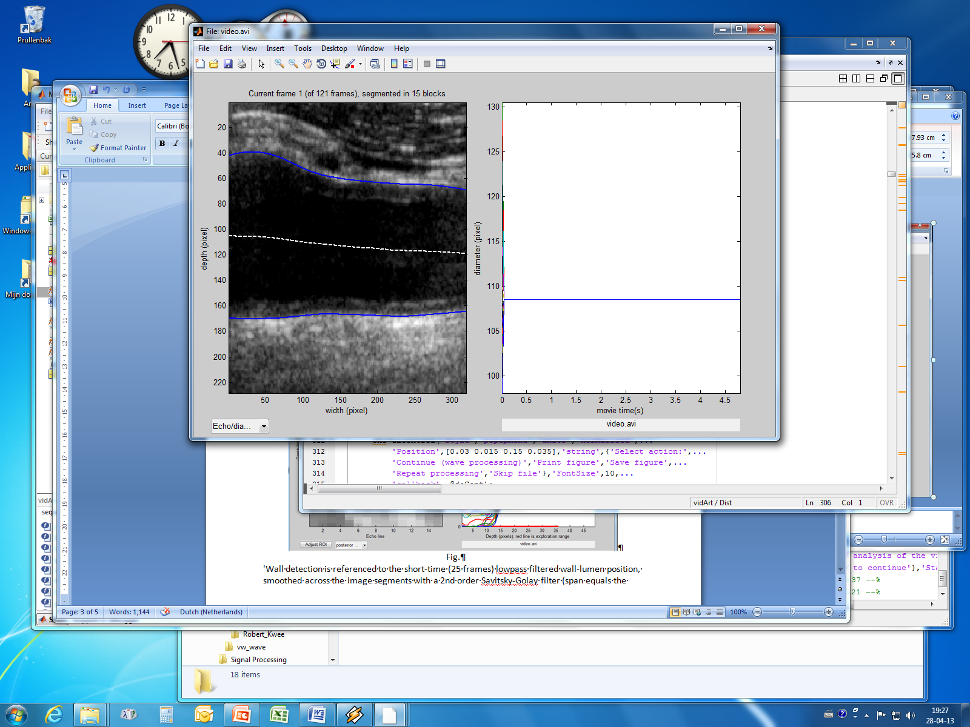

*Fig.4. The lines delineating the near and far artery walls are curved.*

Wall detection is restricted to a narrow strip with a width of about 6 mm symmetrically around the current media-adventitia transition of either the anterior or posterior wall. As a consequence the curved wall position is transformed to a straight line positioned at the middle of the extracted subimage (fig. 5, left panel). Next a search is made for the peak echo, presumably originating from the adventitia, within a region of about 10 resolutions. This region is marked in fig. 5, right panel, with a red line. The new media-adventitia will be the point where, towards the lumen, the echo signal falls below the wall threshold, i.e., a fraction of the peak level. To improve precision, the A-mode lines are interpolated by a factor of 4 prior to wall detection, explaining the smooth A-mode signals in the right panel. Incidental large fluctuations in detected wall position are attenuated by setting them to the mean +/- the standard deviation. After regularization (smoothing filter with a span of 5 points), the observed deviation from the center line position is added to the input wall position, to arrive at an updated distribution of wall positions as input for the next video frame (fig. 4 left frame). The updated artery center line position is compared to the vertical center of the region of interest. If a deviation of more than 2 pixels is observed, the ROI is shifted accordingly in vertical position.

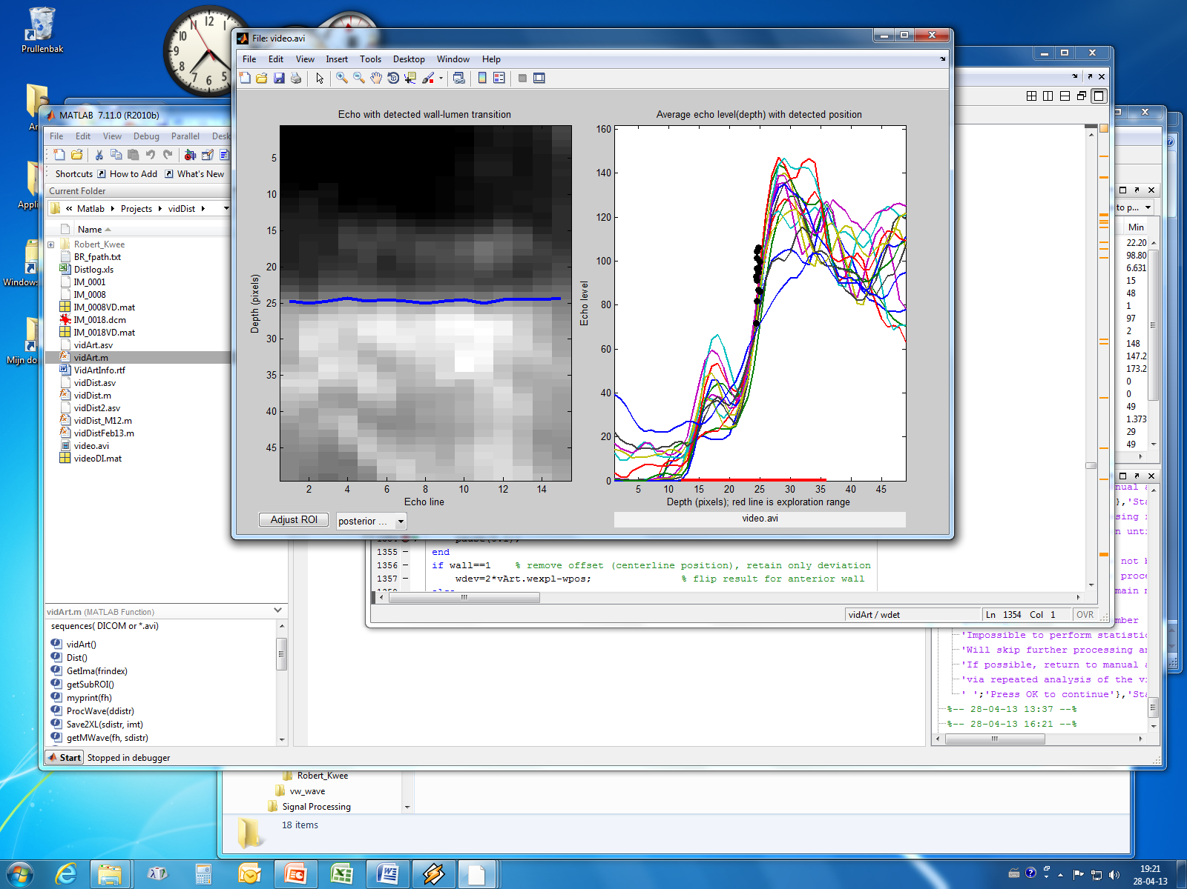

*Fig. 5 Detected posterior wall position (left) for 15 half-overlapping subregions. The right panel displays the A-mode signals for all subregions with superimposed the identified media-adventitia transition. For most subregions the presence of the lumen-intima echo is obvious.*

The adventitia-adventitia artery diameter is the difference between posterior and anterior wall position. While the recursive wall detection procedure progresses, the right panel shows for each subsegment the evolution of the artery diameter over time to arrive eventually at fig.6. The relation between diameter curve (right side) and artery segment (left side) is readily revealed by selecting a curve: the corresponding artery segment will be highlighted.

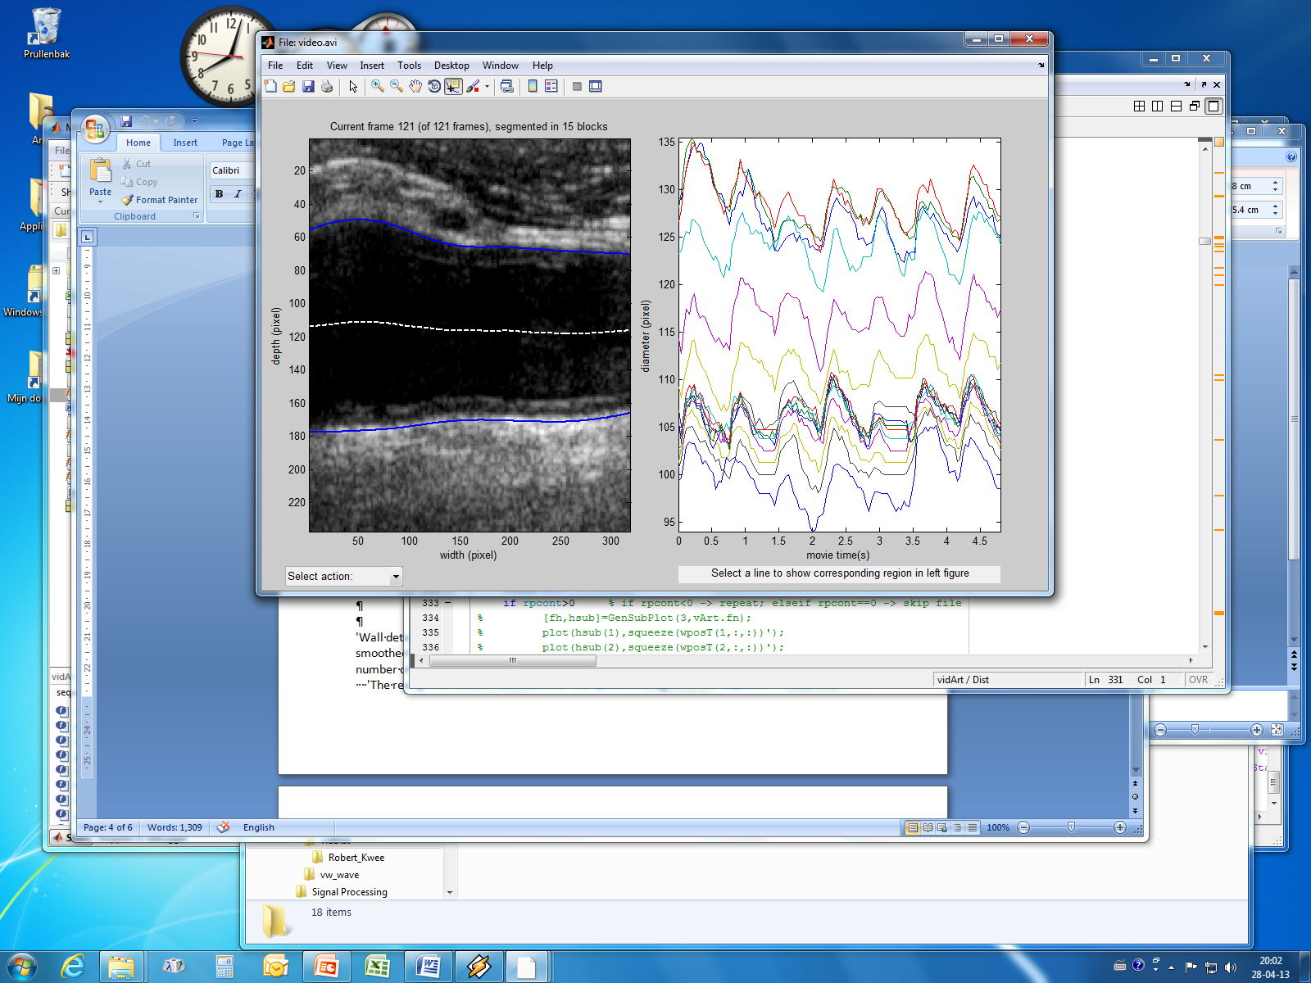

*Fig 6. Left the derived wall position for the last frame. The right panel shows for each subimage the diameter evolution over time.*

At this point the pull-down menu (left bottom) offers the option to skip the current file (poor recording quality), repeat video-processing (improper initialization of artery walls) or to continue with wave processing.

**Wave processing**

The diameter waveforms of fig 6 (left panel) have the same sample rate as the video frame rate, i.e. for a standard avi movie the sample rate will be 25 Hz (sample distance 40 ms). This leaves some room for temporal filtering, considering that the early systolic phase takes about 100 msec. The wave processing section allows to experiment with different settings for temporal filtering and to evaluate visually the result in terms of artifact suppression while the basic features of the distension waveform are retained (fig. 7, middle panel). The dashed signals originate from the left and right edges of the image. The right panel of fig. 7 shows the spatial average of the diameter waveforms (excluding the waveforms at both edges of the ROI). This average diameter waveform clearly exhibits the periodic nature of the blood pressure and allows the detection of the end-diastolic phase (2 frames ahead of the local minimum) as indicated by the markers. The program supports manual editing of the position of those markers for the cardiac cycles, accessible via the pull-down menu at left bottom. This menu also provides some additional information about the menu options.

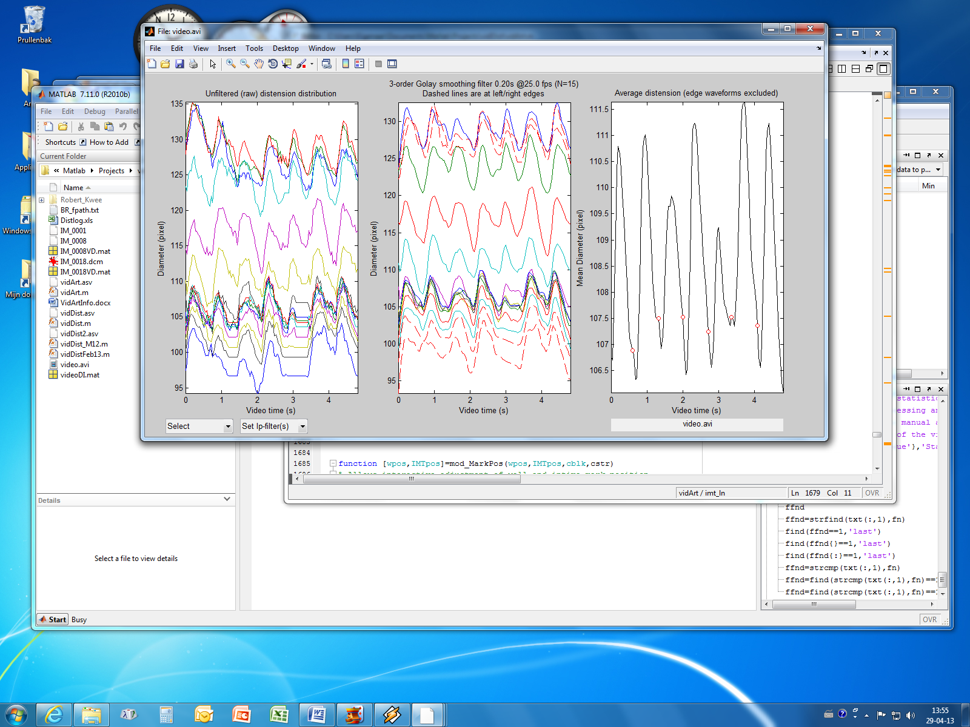

*Fig. 7 Instantaneous diameter waveforms before (left) and after (middle panel) temporal smoothing with a Savitsky-Golay filter with a temporal window of 20 ms. The right panel shows the spatially averaged waveform with markers for the onset of a cardiac cycle*

**Intima detection**

The process of adventitia and intima detection is quite similar. Both approaches consider the spatial average of the echo signal within halfoverlapping subregions after interpolation by a factor 4. However, the adventitia detection heavily depends on amplitude level while intima detection the maximum of the first derivative is considered. The problem is to ascertain the true maximum (the first one inwards from the adventitia or a high one further towards the lumen if the intima/media exhibits additional peaks?). Starting from the adventitia position (red mark figure 8) first a search is made for a local minimum derivative (media). A local minimum/maximum can be established by using a sliding window with a width of about 2 times the depth resolution of the ultrasound system used. Shifting the window one resolution ensures that a peak/valley will be observed twice, indicating a local minimum/maximum. The next local maxima are considered part of the intima-media unless the maximum is lower than a preset threshold (fraction of the first maximum after the minimum).The intima detection process for each subimage can be followed (at a reduced processing rate) by activating the feedback option.

**Manual editing wall/intima position**

Actually intima detection is part of an iterative process starting with manual editing of the anterior and/or posterior adventitia position (fig. 9, left), followed by intima processing with reference to the adjusted posterior wall position, and manual intima adjustment (fig. 9 right). However, intima detection is bypassed if the file was processed before. In that case intermediate results are recalled from a "*.DI.mat"-file (main menu), unless "intima feedback" was activated. Editing of a previously stored intima without feedback avoids repetitive editing.

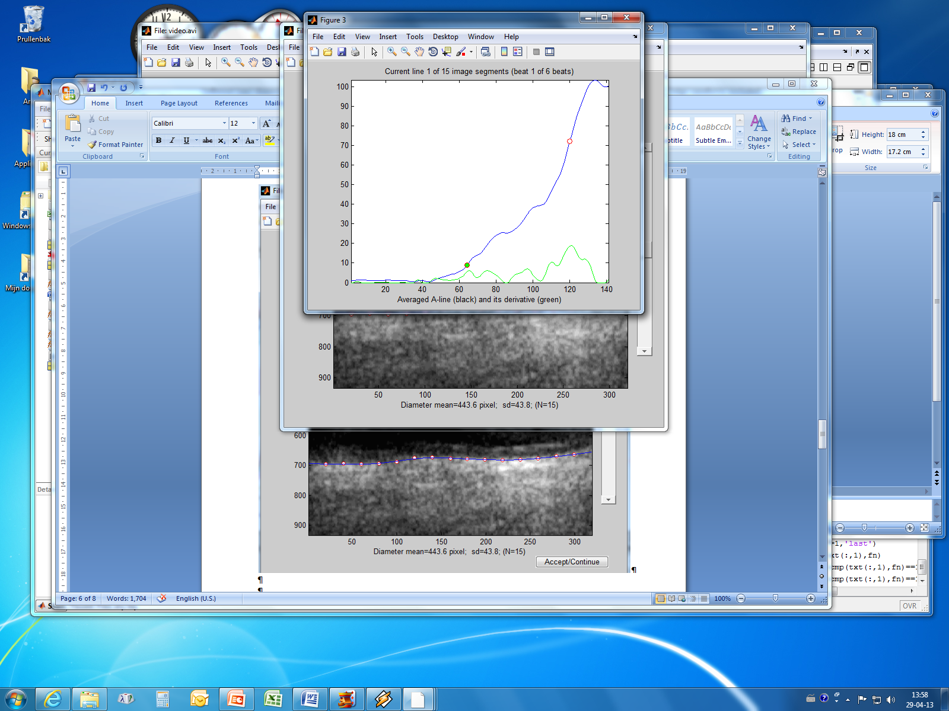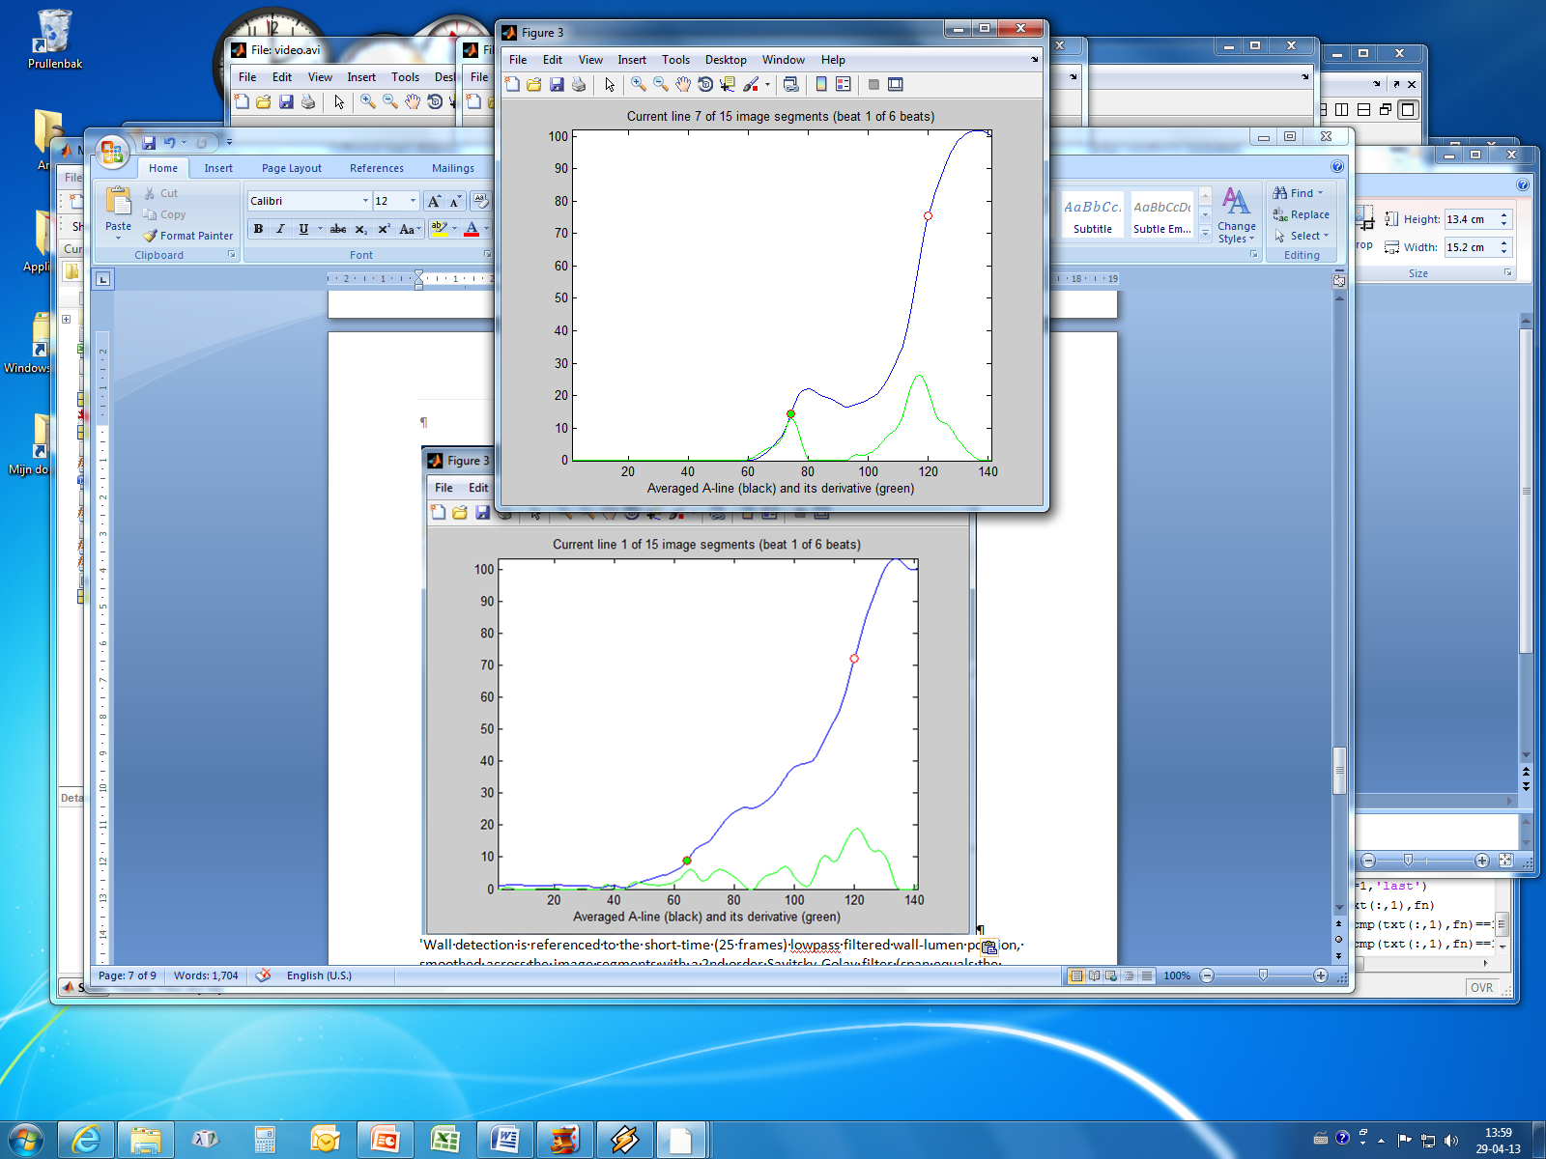

*Fig. 8 Lumen intima detection. The blue line indicates the echo signal for the posterior wall while the green signal pertains to its derivative (scaled by a factor of 5). Starting from the adventitia position (red mark) first a search is made for a minimum (media). The next local maxima are considered part of the intima-media unless the maximum is lower than a preset threshold (fraction of the first maximum after the minimum). For the left panel it is the 3rd peak (green mark) while for the right panel only one clear peak is observed.*

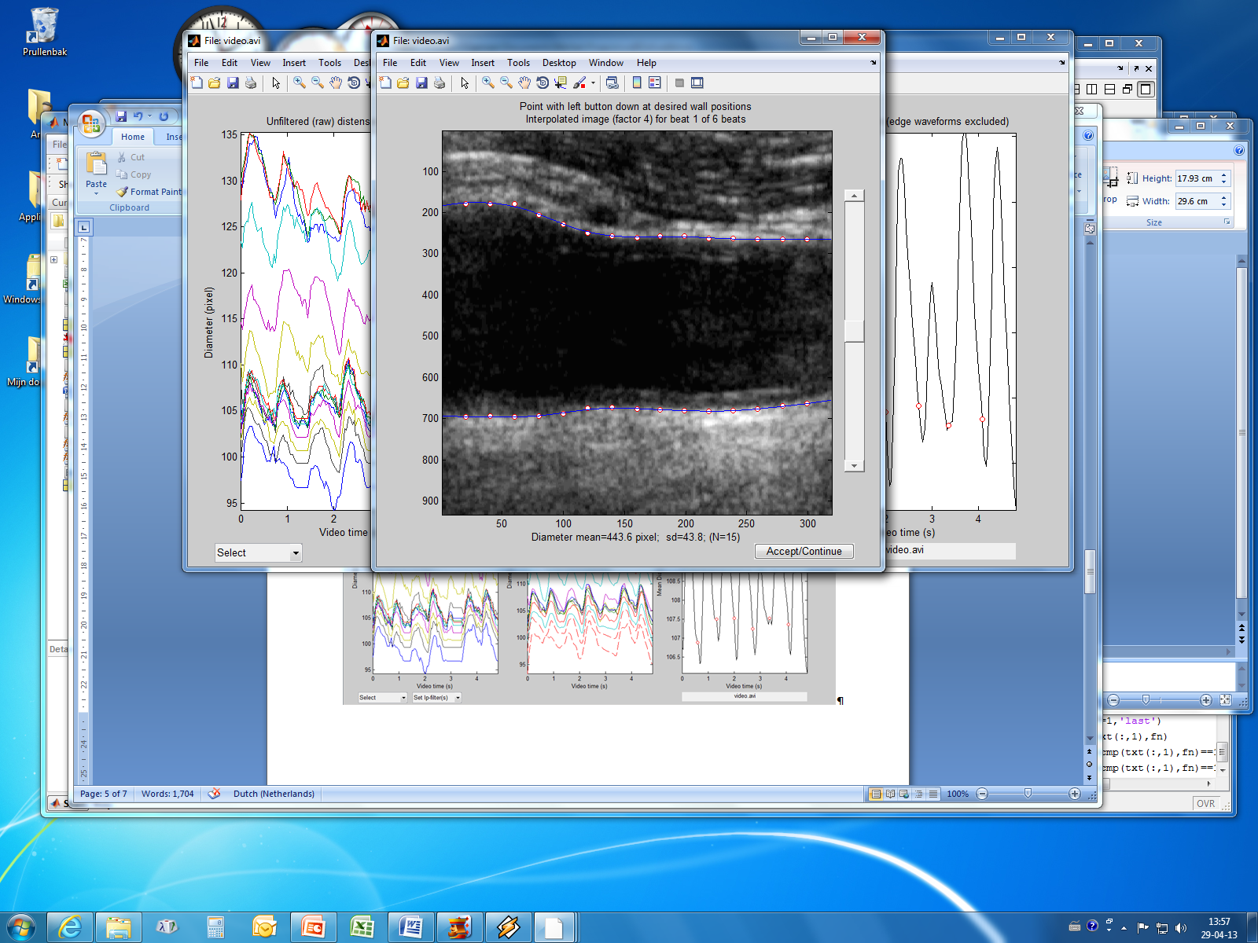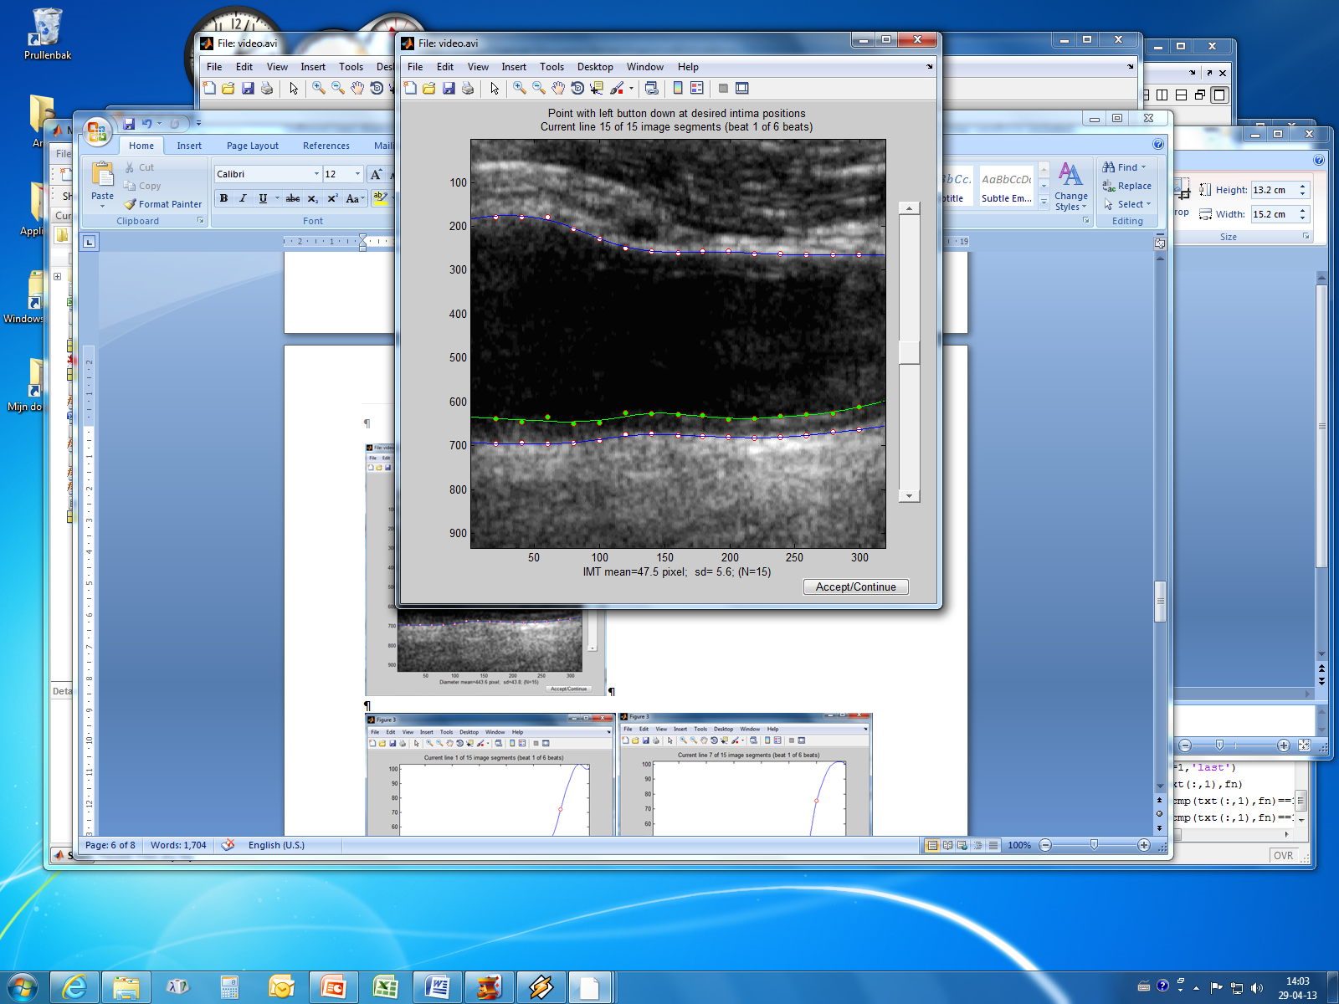

*Fig. 9 Evaluation of the detection process involves adjustment of the wall position (white/red marks) for the subregions (left panel), followed by intima detection and presentation of the result (green line, right panel) which can be manually modified. The process is repeated for all complete cardiac cycles.*

**Program output**

The program generates 3 output-files:

* A matlab-file starting with the name of the video file and terminated with DI.mat. This file contains all intermediate and final outputs of video processing. This file is only for expert users, but is also accessed for reprocessing wall/intima position
* An Excel-file “Distlog.xls’ collecting all parameter settings and processing results for all video files within the selected video data folder. The abbreviations are explained below.
* A text-file for each video-file processed with parameter settings and selected processing results. This file will be compatible with, for example, SPSS.

Note that reprocessing will replace all outputs, so if you want to compare the results of different processing settings, rename the output files or move them to another folder before invoking reprocessing.

**Review/Reprocess/Edit program output**

The matlab –output file allows an easy way to review or to edit results (see the options in the main menu). If you select reprocessing, you will be automatically guided through the settings menu. The updated results get the same file name and, hence, will replace the original file!

**Default setting processing parameters**

vArt.fn='' filename

vArt.FOS=12 text fontsize

vArt.version='Video Dist. V15.08';

vArt.fnr=0 current file number

vArt.nrfiles=0 total number of files to process in this batch

vArt.frbwind=[] image window diameter [X,Y,width,height]

vArt.MinRoiWidth=150 minimal width Region of interest

vArt.ROIwidth=30 default ROI width in terms of mm

vArt.dip=4 depth interpolation factor

vArt.mwexpl=0.8 wall exploration range peak value in mm

vArt.wexpl=[] wall exploration range peak value in pixel

vArt.wthr=0.65 wall threshold relative to peak adventitia

vArt.wthr2=(1+vArt.wthr)/2 threshold for second echo

vArt.ithr=0.6 threshold to search for relevant intime derivative

vArt.dres=0.3 estimated depth US resolution (mm) within ROI

vArt.lres=1.3 estimated lateral US resolution (mm) within ROI

vArt.lwwr=3 lateral window width in terms of lateral resolution

vArt.wspan=7 wall smoothing span in terms of mm

vArt.blksize=40 preferential width (pixels) imagesegment wall detection

vArt.wwidth=40 width (pixels) imagesegment wall detection

vArt.nblk=5 number of image segments for wall detection

vArt.delseg=[] number of ignored/deleted segments at edges

vArt.bshift=1/2 1/2 shift segments (50% overlap)

vArt.sgwind=0.2 smoothing window (s) sgolay-filter distension waveform

vArt.rtop=[] diastolic time points, assumed to be coincident wit R-top

vArt.necg=[] number of R-tops (beats), one more than cardiac cycles

vArt.MinRelDis=2 minimal relative distension [%]

vArt.imt_fb=0 graphical feedback on intima detection (if 1)

vArt.acqdate=[] acquisition date (DICOM)-file

vArt.fps=25 default frames per second

vArt.nfr=100 default (minimum) number of frames

vArt.tmax=6 long video clips will be truncated to 'tmax' seconds

vArt.rWidth=[] number of echo lines within ROI

vArt.rDepth=[] number of videolines (pixels) within ROI

vArt.rtthr=[10 90] lower and upper distension thresholds for risetime

vArt.pixscal=1 pixel scaling dimension; pixelsize in MM!!

vArt.proc=1 (RE-)process only distension (0) or distension AND IMT

vArt.rproc=0 0 is normal analysis, else reprocessing

vArt.probe='' probe identifier

vArt.mfext='DI.mat' extension for mat file with intermediate results

vArt.source='*.avi' video source, either *.avi, bmode (VEVO) or DICOM

vArt.log='Distlog.xls';

**Abbreviations in Excel output file**

*File & processing parameters*

File video file name

Source *.avi or *.dcm (DICOM) or no extension

fps(Hz) frames per second

nfr total number of frames within considered time fragment

rec.time recording time in seconds

Depth depth range (pixels) of Region of Interest (ROI)

Width width of ROI (pixels)

PixSize pixel distance in mm (only for DICOM-recordings), otherwise 1

Dres estimated depth resolution US system

Lres estimated lateral resolution US system

Blksize blocksize of subimage segment wall/intima identification (pixels)

Nrblks Number of blocks (subsegments) within ROI

Blkshift block shift (0.5 means half-overlapping)

sm.window(s) length smoothing window Savitsky-Golay filter

ECG-cycles number of complete cardiac cycles(truncated at 6)

ECG-bpm Heart rate (beats per minute)

Wall threshold Threshold wall detection (0.65)

Intima threshold Threshold for intima detection (0.6)

Risetime threshold Threshold for risetime detection distension waveform (10/90 %)

*Processing outputs*

Most of the outputs have a spatial (along the artery) as well as a temporal (heart beats) distribution. Those outputs have a mean and median value plus standard deviation. The temporal direction is indicated with the suffix mn, med and sd while the spatial direction will be labeled smn, smed and ssd. For example the diameter obtained via the median across the image and averaging over beats will be labeled “diam.smd.mn” (18 parameters):

Ddiast.smn.mn spatial and temporal average of diastolic diameter

Ddiast.smn.med spatial mean, temporal median diastolic diameter

Ddiast.smn.sd temporal standard deviation of spatial mean diastolic diameter

Dsyst.smn.mn spatial and temporal average of systolic diameter

Dsyst.smn.med spatial mean, temporal median of systolic diameter

Dsyst.smn.sd temporal standard deviation of spatial mean systolic diameter

Ddist.smn.mn spatial and temporal average of distension (systolic minus diastolic

diameter)

Ddist.smn.med spatial mean, temporal median of distension

Ddist.smn.sd temporal standard deviation of spatial mean distension

Ddiast.smed.mn spatial median and temporal average of diastolic diameter

Ddiast.smed.med spatial median, temporal median of diastolic diameter

Ddiast.smed.sd temporal standard deviation of spatial median diastolic diameter

Dsyst.smed.mn spatial median and temporal average of systolic diameter

Dsyst.smed.med spatial median, temporal median of systolic diameter

Dsyst.smed.sd temporal standard deviation of spatial median systolic diameter

Ddist.smed.mn spatial median and temporal average of distension

Ddist.smed.med spatial median, temporal median distension

Ddist.smed.sd temporal standard deviation of spatial median distension

The spatial homogeneity (morphological uniformity) is quantified by the spatial standard deviation. To avoid confusion about the nature of the measures, ‘hom’ is reserved for the spatial standard deviation (9 parameters):

Ddiast.shom.mn temporal average of spatial homogeneity of diastolic diameter

Ddiast.shom.med temporal median of spatial homogeneity of diastolic diameter

Ddiast.shom.sd temporal standard deviation of spatial homogeneity of diastolic diameter

Dsyst.shom.mn temporal average of spatial homogeneity of systolic diameter

Dsyst.shom.med temporal median of spatial homogeneity of systolic diameter

Dsyst.shom.sd temporal standard deviation of spatial homogeneity of systolic diameter

Ddist.shom.mn temporal average of spatial homogeneity distension

Ddist.shom.med temporal median of spatial homogeneity distension

Ddist.shom.sd temporal standard deviation of spatial homogeneity distension

The above approach is also followed for the average diameter waveform (but this one does not have a spatial distribution). Note that only the temporal mean of the average waveform should be the same as the spatial and temporal mean of the diameter distribution (linear operations):

Ddiast.A.mn temporal average of diastolic diameter

Ddiast.A.med temporal median of diastolic diameter

Ddiast.A.sd temporal standard deviation of diastolic diameter

Dsyst.A.mn temporal average of systolic diameter

Dsyst.A.med temporal median of systolic diameter

Dsyst.A.sd temporal standard deviation of systolic diameter

Ddist.A.mn temporal average of distension

Ddist.A.med temporal median of distension

Ddist.A.sd temporal standard deviation of distension

For the intima-media thickness (IMT) of the posterior wall (9 parameters):

IMT.smn.mn spatial and temporal mean of IMT

IMT.smn.med temporal median of spatial mean of IMT

IMT.smn.sd temporal standard deviation of spatial mean IMT

IMT.smed.mn spatial and temporal median IMT

IMT.smed.med temporal median of spatial median IMT

IMT.smed.sd temporal standard deviation of spatial median of IMT

IMT.shom.mn temporal mean of spatial homogeneity of IMT

IMT.shom.med temporal median of spatial homogeneity of IMT

IMT.shom.sd temporal standard deviation of spatial homogeneity of IMT

The IMT/diameter ratio is normally quite constant and will be on the order of 10%. In this application we have the relative IMT (rIMT) defined as the ratio of the local IMT and local diameter or the ratio of the spatial means of IMT and diastolic diameter. So we get (9 parameters):

rIMT.smn.mn spatial and temporal mean of rIMT

rIMT.smn.med temporal median of spatial mean of rIMT

rIMT.smn.sd temporal standard deviation of spatial mean of rIMT

rIMT.smed.mn spatial and temporal median of rIMT

rIMT.smed.med temporal median of spatial median of rIMT

rIMT.smed.sd temporal standard deviation of spatial median of rIMT

rIMT.shom.mn temporal mean of spatial homogeneity of rIMT

rIMT.shom.med temporal median of spatial homogeneity of rIMT

rIMT.shom.sd temporal standard deviation of spatial homogeneity of rIMT

Alternatively one may consider the ratio of the means (rather than mean/median/sd of the ratio), i.e., 3 parameters:

rIMT.A.mn mean of relative IMT (mean wall thickness over mean diameter)

rIMT.A.med median of relative IMT

rIMT.A.sd standard deviation of relative IMT

The same approach is followed for the relative distension (9 parameters):

rDist.smn.mn spatial and temporal mean of relative distension (rDist)

rDist.smn.med temporal median of spatial mean of rDist

rDist.smn.sd temporal standard deviation of spatial mean of rDist

rDist.smed.mn spatial and temporal median of rDist

rDist.smed.med temporal median of spatial median of rDist

rDist.smed.sd temporal standard deviation of spatial median of rDist

rDist.shom.mn temporal mean of spatial homogeneity rDist

rDist.shom.med temporal median of spatial homogeneity rDist

rDist.shom.sd temporal standard deviation of spatial homogeneity rDist

And for the ratio of the means (3 parameters):

rDist.A.mn mean of relative distension

rDist.A.med median of relative distension

rDist.A.sd standard deviation of relative distension

Traditionally the maximum observed IMT within the field of view is considered indicative for wall abnormalities. This is also reported per beat:

IMT.max.mn mean of maximum IMT

IMT.max.med median of maximum IMT

IMT.max.sd standard deviation of maximum IMT

The only waveform outputs that are still missing are the systolic rise times which have the same structure as the diameter (9 parameters):

RT.smn.mn spatial and temporal mean of risetime

RT.smn.med temporal median of spatial mean of risetime

RT.smn.sd temporal standard deviation of spatial mean of risetime

RT.smed.mn spatial and temporal median of risetime

RT.smed.med temporal median of spatial median of risetime

RT.smed.sd temporal standard deviation of spatial median of risetime

RT.shom.mn temporal mean of spatial homogeneity of risetime

RT.shom.med temporal median of spatial homogeneity of risetime

RT.shom.sd temporal standard deviation of spatial homogeneity of risetime

And for the average waveform (3 parameters):

RT.A.mn temporal mean risetime of average waveform

RT.A.med temporal median risetime of average waveform

RT.A.sd temporal standard deviation risetime of average waveform

And finally:

The RR-interval (time interval between R-tops electrocardiogram) is derived from the average diameter waveform and is the most obvious output (3 parameters):

RR.mn mean of RR-intervals (ms)

RR.med median of RR-intervals (ms)

RR.std standard deviation of RR-intervals (ms)

This gives in total 88 waveform-related parameters!

Arnold Hoeks, Aug 2015

Dept. Biomedical Engineering, Maastricht University.

vidArt Version V15.8